Certificate Annex
Acumen Waste Services Limited
Annex 1 of 1 to Certificate number 5081-QMS/EMS/SSP - 001 containing four locations including Head Office
02 January 2018
ISO 9001: 2015, ISO 14001: 2015, BS OHSAS 18001 2007 SSIP
Scope of Registration:
The provision of waste management services, including the processing of waste oils.
HEAD OFFICE
001 Acumen House, Headlands Lane, Knottingley, West Yorkshire, WFII OLA
OTHER LOCATIONS
003 Lincoln Street, Wolverhampton, WV 10 ODZ
004 Acumen Energy Limited
Lincoln Street, Wolverhampton, WVIO ODZ
005 Acumen Recovery Park, The Old Brick a\nd tile Works, Riccall Road, Escrick, York, Y019 6ED
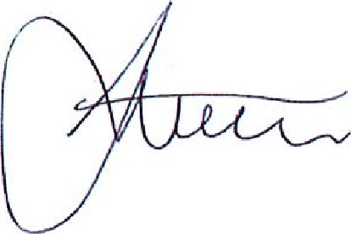
Signed:
Steve Stubley, Technical Director (on behalf of Alcumus ISOQAR)
F:

Certificate of Registration
This is to certify that the Management System of:
Acumen Waste Services Limited
Acumen House, Headlands Lane, Knottingley, West Yorkshire, WFII OLA
has been approved by Alcumus ISOQAR and is compliant with the requirements of:
BS OHSAS 18001: 2007
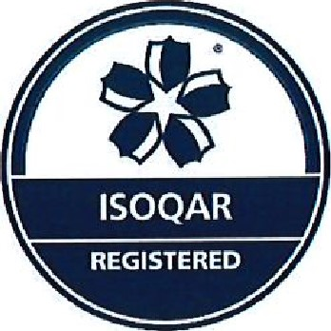
Certificate Number: 5081-SSP - 001
Initial Registration Date: 4 December 2013
Re-issue Date: 2 January 2018
Expiry Date: 10 January 2021 ssLP SAFE'l'h
SCHEMES IN
PROCUREMENT
Scope of Registration:
The provision of waste management services, including the processing of waste oils.
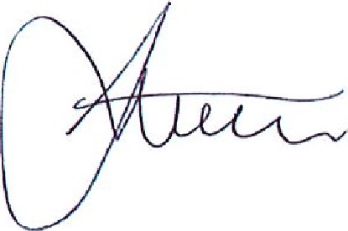
Signed:
Steve Stubley, Technical Director (on behalf of Alcumus ISOQAR)
F

Certificate of Registration
This is to certify that the Management System of:
Acumen Waste Services Limited
Acumen House, Headlands Lane, Knottingley, West Yorkshire, WFII OLA
has been approved by Alcumus ISOQAR and is compliant with the requirements of:
BS OHSAS 18001: 2007
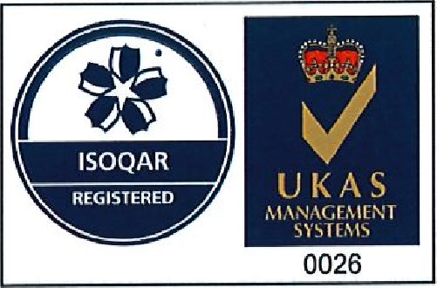
Certificate Number: 5081-HAS - 001
Initial Registration Date: 4 December 2013
Re-issue Date: 2 January 2018
Expiry Date: 10 January 2021
Scope of Registration:
The provision of waste management services, including the processing of waste oils.
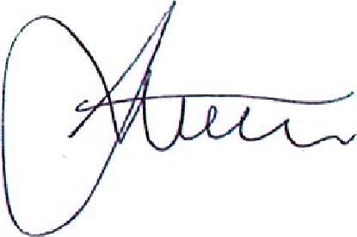
Signed:
Steve Stubley, Technical Director
(on behalf of Alcumus ISOQAR)
This certificate will remain current subject to the company maintaining its system to the required standard. This will be monitored regularly by Alcumus ISOQAR. Further clarification regarding the scope of this certificate and the applicability of the relevant standards' requirements may be obtained by consulting Alcumus ISOQAR.
This certificate is one of several issued to registration number 5081

Certificate of Registration
This is to certify that the Management System of:
Acumen Waste Services Limited
Lincoln Street, Wolverhampton, WVIO ODZ
has been approved by Alcumus ISOQAR and is compliant with the requirements of:
BS OHSAS 18001: 2007
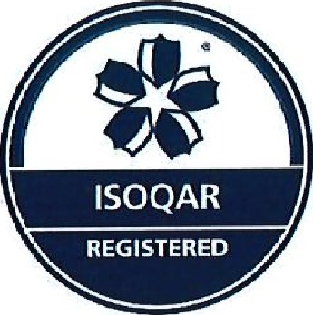
Certificate Number: 5081-SSP - 003
Initial Registration Date: 4 December 2013
Re-issue Date: 2 January 2018
Expiry Date: 10 January 2021 ssLP SAFE'I'Y
SCHEMES IN
PROCUREMENT
Scope of Registration:
The provision of waste management services, including the processing of waste oils.
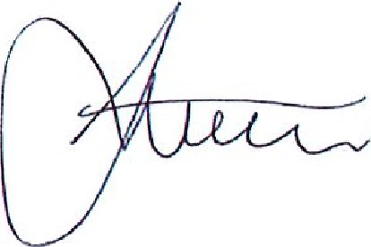
Signed:
Steve Stubley, Technical Director
(on behalf of Alcumus ISOQAR)

Certificate of Registration
This is to certify that the Management System of:
Acumen Waste Services Limited
Lincoln Street, Wolverhampton, WVIO ODZ
has been approved by Alcumus ISOQAR and is compliant with the requirements of:
BS OHSAS 18001: 2007
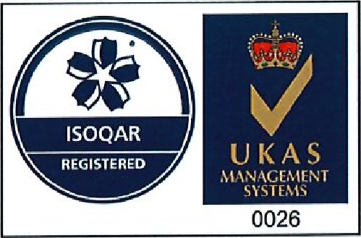
Certificate Number: 5081-HAS - 003
Initial Registration Date: 4 December 2013
Re-issue Date: 2 January 2018
Expiry Date: 10 January 2021
Scope of Registration:
The provision of waste management services, including the processing of waste oils.
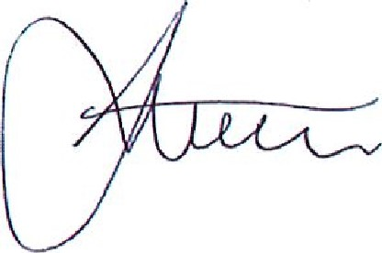
Signed:
Steve Stubley, Technical Director
(on behalf of Alcumus ISOQAR)
This certificate will remain current subject to the company maintaining its system to the required standard. This will be monitored regularly by Alcumus ISOQAR. Further clarification regarding the scope of this certificate and the applicability of the relevant standards' requirements may be obtained by consulting Alcumus ISOQAR. This certificate is one of several issued to registration number 5081
T

Certificate of Registration
This is to certify that the Management System of:
Acumen Waste Services Limited
Acumen Energy Limited, Lincoln Street, Wolverhampton, WVIO ODZ
has been approved by Alcumus ISOQAR and is compliant with the requirements of:
BS OHSAS 18001: 2007
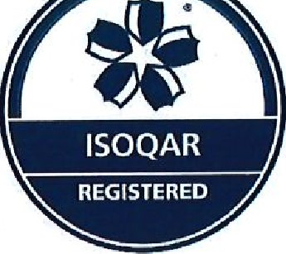
Certificate Number: 5081-SSP - 004
Initial Registration Date: 4 December 2013
Re-issue Date: 2 January 2018
Expiry Date: 10 January 2021 ss1P SAFIV1iY
SCHEMES IN
PROCUREMENT
Scope pf Registration:
The provision of waste management services, including the processing of waste oils.
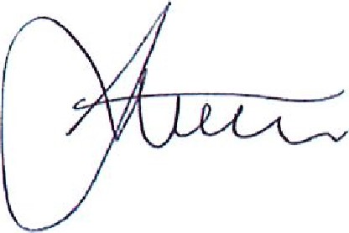
Signed:
Steve Stubley, Technical Director
(on behalf of Alcumus ISOQAR)

Certificate of Registration
This is to certify that the Management System of:
Acumen Waste Services Limited
Acumen Energy Limited, Lincoln Street, Wolverhampton, WVIO ODZ,
has been approved by Alcumus ISOQAR and is compliant with the requirements of:
BS OHSAS 18001: 2007
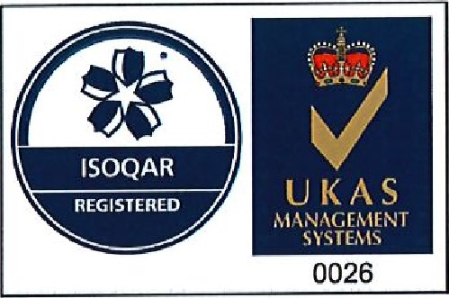
Certificate Number: 5081-HAS -004
Initial Registration Date: 4 December 2013
Re-issue Date: 2 January 2018
Expiry Date: 10 January 2021
Scope of Registration:
The provision of waste management services, including the processing of waste oils.
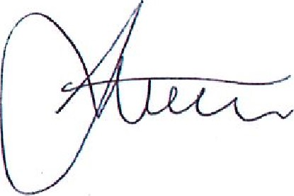
Signed:
Steve Stubley, Technical Director
(on behalf of Alcumus ISOQAR)
This certificate will remain current subject to the company maintaining its system to the required standard. This will be monitored regularly by Alcumus ISOQAR. Further clarification regarding the scope of this certificate and the applicability of the relevant standards' requirements may be obtained by consulting Alcumus ISOQAR.
This certificate is one of several issued to registration number 5081 , w:

Certificate of Registration
This is to certify that the Management System of:
Acumen Waste Services Limited
Acumen Recovery Park, The Old Brick and Tile Works, Riccall Road, Escrick, York, Y019 GED
has been approved by Alcumus ISOQAR and is compliant with the requirements of:
BS OHSAS 18001: 2007
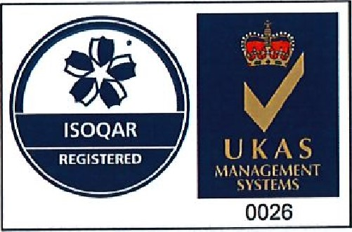
Certificate Number: 5081-HAS - 005
Initial Registration Date: 21 September 2016
Re-issue Date: 2 January 2018
Expiry Date: 10 January 2021
Scope of Registration:
The provision of waste management services, including the processing of waste oils.
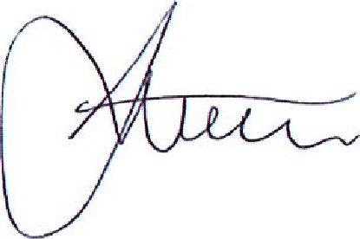
Signed:
Steve Stubley, Technical Director
(on behalf of Alcumus ISOQAR)
This certificate will remain current subject to the company maintaining its system to the required standard, This will be monitored regularly by Alcumus ISOQAR. Further clarification regarding the scope of this certificate and the applicability of the relevant standards' requirements may be obtained by consulting Alcumus ISOQAR.
This certificate is one of several issued to registration number 5081

Certificate of Registration
This is to certify that the Management System of:
Acumen Waste Services Limited
Acumen Recovery Park, The Old Brick and Tile Works, Riccall Road, Escrick, York, Y019 GED
has been approved by Alcumus ISOQAR and is compliant with the requirements of:
BS OHSAS 18001: 2007
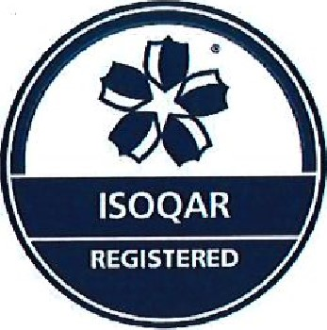
Certificate Number: 5081-SSP - 005
Initial Registration Date: 21 September 2016
Re-issue Date: 2 January 2018
Expiry Date: 10 January 2021 ss1P SAFETY
SCHEMES IN
PROCUREMENT
Scoue of Registration:
The provision of waste management services, including the processing of waste oils.
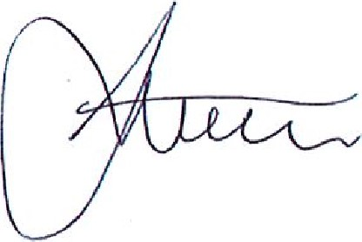
Signed:
Steve Stubley, Technical Director
(on behalf of Alcumus ISOQAR)
This certificate will remain current subject to the company maintaining its system to the required standard. This will be monitored regularly by Alcumus ISOQAR. Further clarification regarding the scope of this certificate and the applicability of the relevant standards' requirement may be obtained by consulting Alcumus ISOQAR. This certificate is one of several issued to registration number 5081
F E:

Certificate of Registration
This is to certify that the Management System of:
Acumen Waste Services Limited
Acumen House, Headlands Lane, Knottingley, West Yorkshire, WFII OLA
has been approved by Alcumus ISOQAR and is compliant with the requirements of:
ISO 14001: 2015
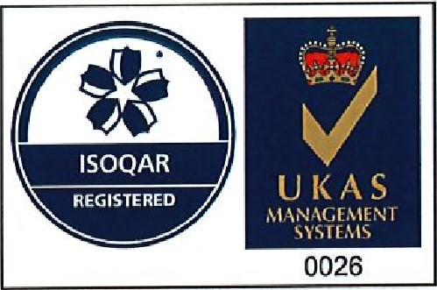
Certificate Number: 5081-EMS - 001
Initial Registration Date: 10 January 2006
Re-issue Date: 2 January 2018
Expiry Date: 10 January 2021
Scope of Registration:
The provision of waste management services, including the processing of waste oils.
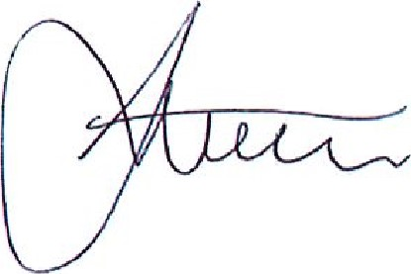
Signed:
Steve Stubley, Technical Director
(on behalf of Alcumus ISOQAR)
This certificate will remain current subject to the company maintaining its system to the required standard. This will be monitored regularly by Alcumus ISOQAR. Further clarification regarding the scope of this certificate and the applicability of the relevant standards' requirements may be obtained by consulting Alcumus ISOQAR. This certificate is one of several issued to registration number 5081.

Certificate of Registration
This is to certify that the Management System of:
Acumen Waste Services Limited
Lincoln Street, Wolverhampton, WVIO ODZ
has been approved by Alcumus ISOQAR and is compliant with the requirements of:
ISO 14001: 2015
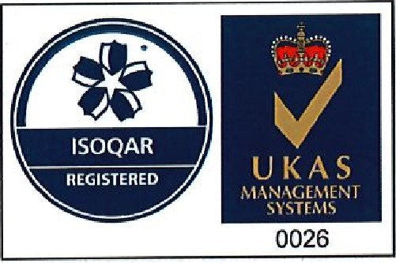
Certificate Number: 5081-EMS - 003
Initial Registration Date: 10 January 2006
Re-issue Date: 2 January 2018
Expiry Date: 10 January 2021
Scope of Registration:
The provision of waste management services, including the processing of waste oils.
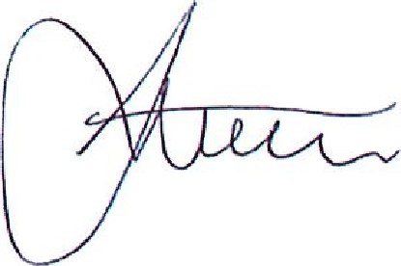
Signed:
Steve Stubley, Technical Director
(on behalf of Alcumus ISOQAR)
This certificate will remain current subject to the company maintaining its system to the required standard. This will be monitored regularly by Alcumus ISOQAR. Further clarification regarding the scope of this certificate and the applicability of the relevant standards' requirements may be obtained by consulting Alcumus ISOQAR.
This certificate is one of several issued to registration number 5081.
F:

Certificate of Registration
This is to certify that the Management System of:
Acumen Waste Services Limited
Acumen Energy Limited, Lincoln Street, Wolverhampton, WVIO ODZ
has been approved by Alcumus ISOQAR and is compliant with the requirements of:
ISO 14001: 2015
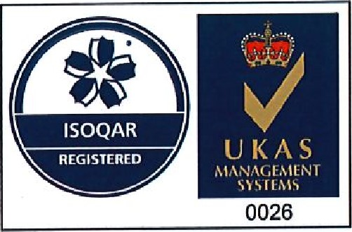
Certificate Number: 5081-EMS - 004
Initial Registration Date: 23 May 2012
Re-issue Date: 2 January 2018
Expiry Date: 10 January 2021
Scope of Registration:
The provision of waste management services, including the processing of waste oils.
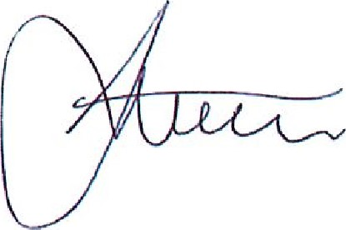
Signed:
Steve Stubley, Technical Director
(on behalf of Alcumus ISOQAR)
This certificate will remain current subject to the company maintaining its system to the required standard, This will be monitored regularly by Alcumus ISOQAR. Further clarification regarding the scope of this certificate and the applicability of the relevant standards' requirements may be obtained by consulting Alcumus ISOQAR,
This certificate is one of several issued to registration number 5081.
T

Certificate of Registration
This is to certify that the Management System of:
Acumen Waste Services Limited
Acumen Recovery Park, The Old Brick and Tile Works, Riccall Road, Escrick, York, Y019 GED has been approved by Alcumus ISOQAR and is compliant with the requirements of:
ISO 14001: 2015
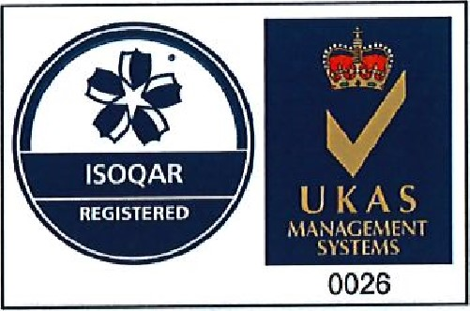
Certificate Number: 5081-EMS - 005
Initial Registration Date: 21 September 2016
Re-issue Date: 2 January 2018
Expiry Date: 10 January 2021
Scope of Registration:
The provision of waste management services, including the processing of waste oils.
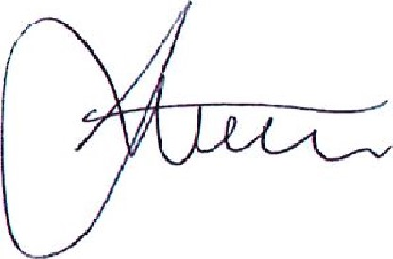
Signed:
Steve Stubley, Technical Director
(on behalf of Alcumus ISOQAR)
This certificate will remain current subject to the company maintaining its system to the required standard. This will be monitored regularly by Alcumus ISOQAR. Further clarification regarding the scope of this certificate and the applicability of the relevant standards' requirements may be obtained by consulting Alcumus ISOQAR. This certificate is one of several issued to registration number 5081
F:

Certificate of Registration
This is to certify that the Management System of:
Acumen Waste Services Limited
Acumen House, Headlands Lane, Knottingley, West Yorkshire, WFII OLA
has been approved by Alcumus ISOQAR and is compliant with the requirements of:
ISO 9001: 2015
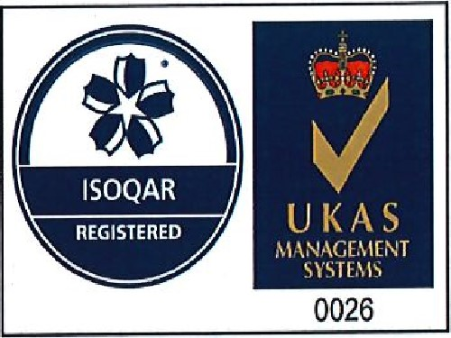
Certificate Number: 5081-QMS - 001
Initial Registration Date: 10 January 2006
Re-issue Date: 2 January 2018
Expiry Date: 10 January 2021
Scope of Registration:
The provision of waste management services, including the processing of waste oils.
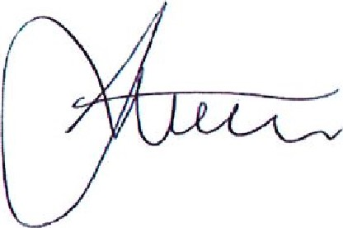
Signed:
Steve Stubley, Technical Director
(on behalf of Alcumus ISOQAR)
This certificate will remain current subject to the company maintaining its system to the required standard. This will be monitored regularly by Alcumus ISOQAR& Further clarification regarding the scope of this certificate and the applicability of the relevant standards' requirements may be obtained by consulting Alcumus ISOQAR. This certificate is one of several issued to registration number 5081.
W:

Certificate of Registration
This is to certify that the Management System of:
Acumen Waste Services Limited
Lincoln Street, Wolverhampton, WVIO ODZ
has been approved by Alcumus ISOQAR and is compliant with the requirements of:
ISO 9001: 2015
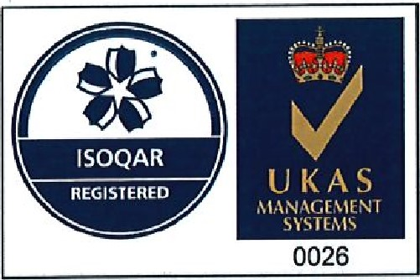
Certificate Number: 5081-QMS - 003
Initial Registration Date: 10 January 2006
Re-issue Date: 2 January 2018
Expiry Date: 10 January 2021
Scope of Registration:
The provision of waste management services, including the processing of waste oils.
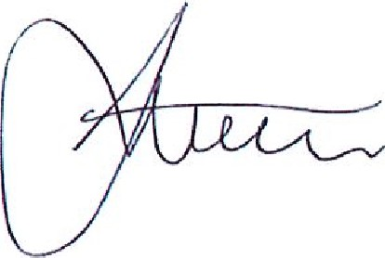
Signed:
Steve Stubley, Technical Director
(on behalf of Alcumus ISOQAR)
This certificate will remain current subject to the company maintaining its system to the required standard. This will be monitored regularly by Alcumus ISOQAR. Further clarification regarding the scope of this certificate and the applicability of the relevant standards' requirements may be obtained by consulting Alcumus ISOQAR This certificate is one of several issued to registration number 5081

Certificate of Registration
This is to certify that the Management System of:
Acumen Waste Services Limited
Acumen Energy Limited, Lincoln Street, Wolverhampton, WVIO ODZ
has been approved by Alcumus ISOQAR and is compliant with the requirements of:
ISO 9001: 2015
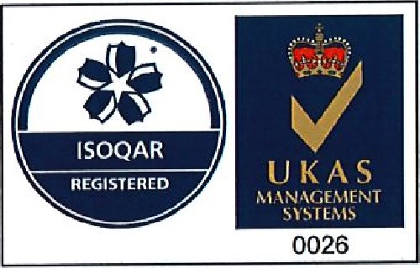
Certificate Number: 5081-QMS - 004 Initial Registration Date: 23 May 2012
Re-issue Date: 2 January 2018
Expiry Date: 10 January 2021
Scope of Registration:
The provision of waste management services, including the processing of waste oils.
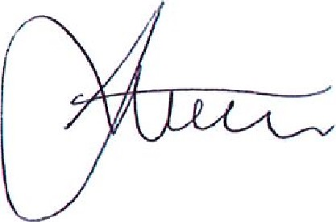
Signed:
Steve Stubley, Technical Director
(on behalf of Alcumus ISOQAR)
This certificate will remain current subject to the company maintaining its system to the required standard. This will be monitored regularly by Alcumus ISOQAR. Further clarification regarding the scope of this certificate and the applicability of the relevant standards' requirements may be obtained by consulting Alcumus ISOQAR. This certificate is one of several issued to registration number 5081.

Certificate of Registration
This is to certify that the Management System of:
Acumen Waste Services Limited
Acumen Recovery Park, The Old Brick and Tile Works, Riccall Road, Escrick, York, Y019 6ED
has been approved by Alcumus ISOQAR and is compliant with the requirements of:
ISO 9001: 2015
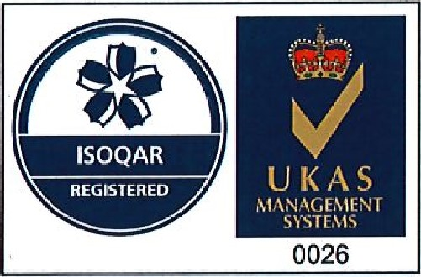
Certificate Number: 5081-QMS - 005
Initial Registration Date: 21 September 2016
Re-issue Date: 2 January 2018
Expiry Date: 10 January 2021
Scope of Registration:
The provision of waste management services, including the processing of waste oils.
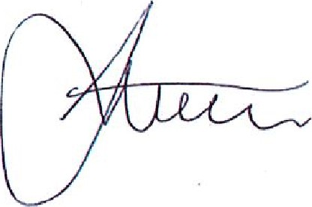
Signed:
Steve Stubley, Technical Director
(on behalf of Alcumus ISOQAR)
This certificate will remain current subject to the company maintaining its system to the required standard. This will be monitored regularly by Alcumus ISOQAR, Further clarification regarding the scope of this certificate and the applicability of the relevant standards' requirements may be obtained by consulting Alcumus ISOQAR. This certificate is one of several issued to registration number 5081
E:

